Author

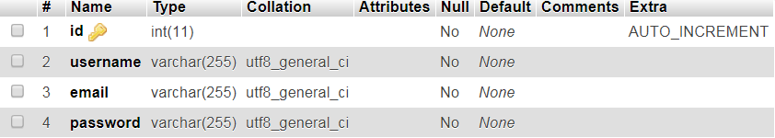

Articles

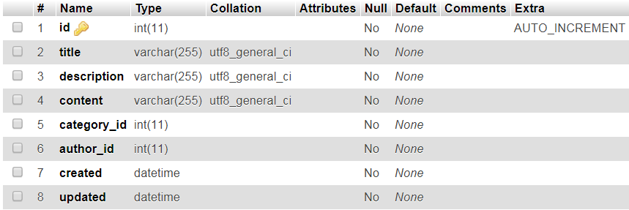

Categories

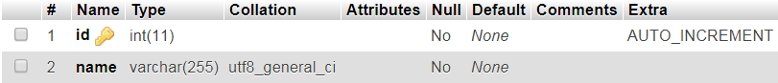

Comment

